**PLOTS: SIGNUM FUNCTION**

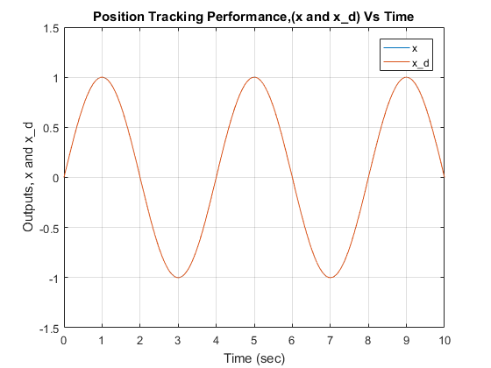

**Figure 1:** Position Tracking Performance

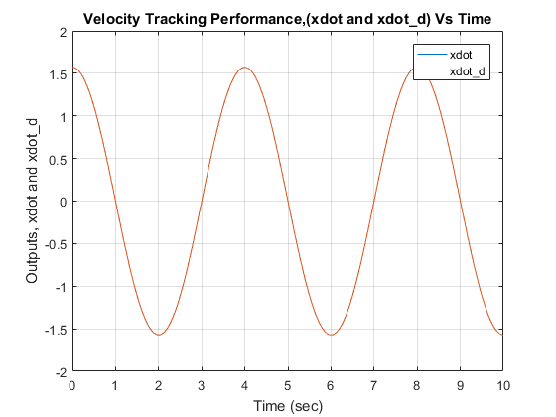

**Figure 2:** Velocity Tracking Performance

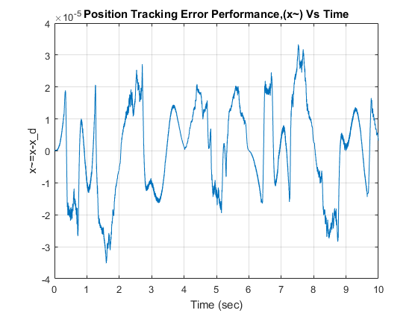

**Figure 3:** Position Tracking Error Performance

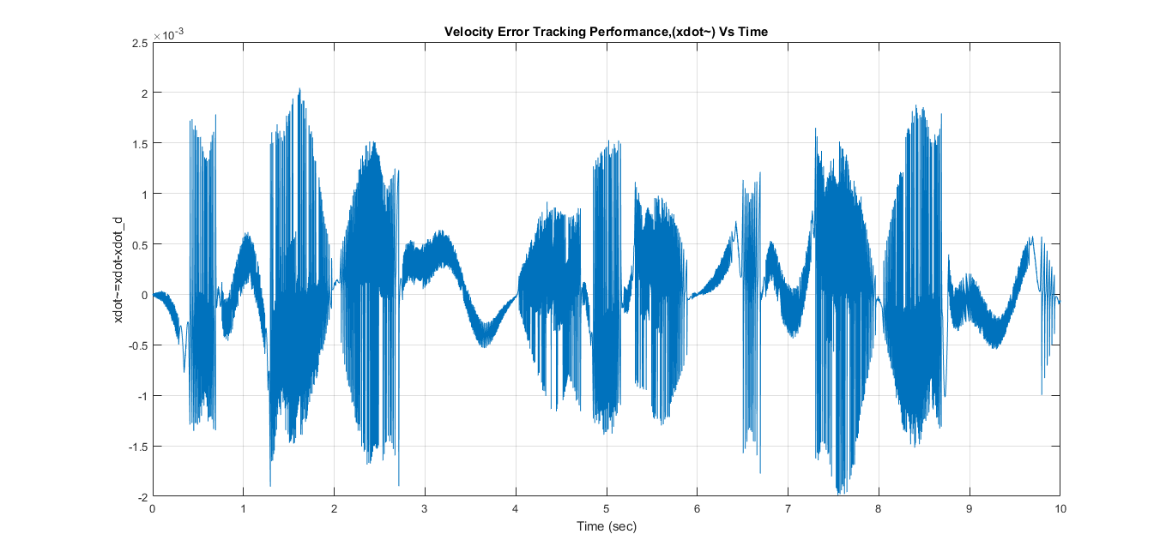

**Figure 4:** Velocity Tracking Error Performance

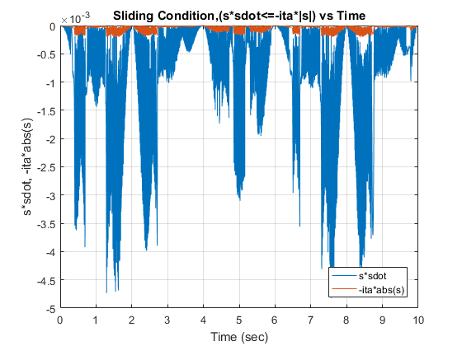

**Figure 5:** Sliding Condition

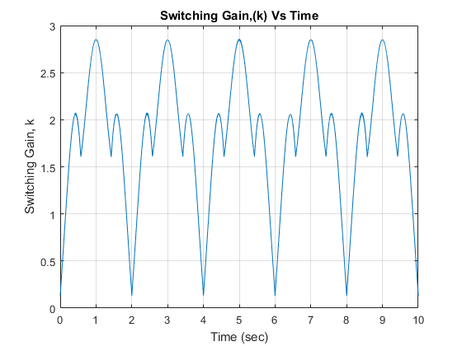

**Figure 6:** Switching Gain

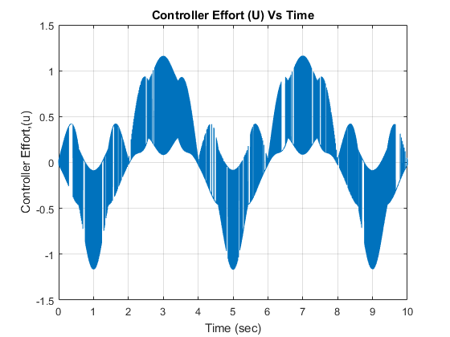

**Figure 7:** Controller Effort

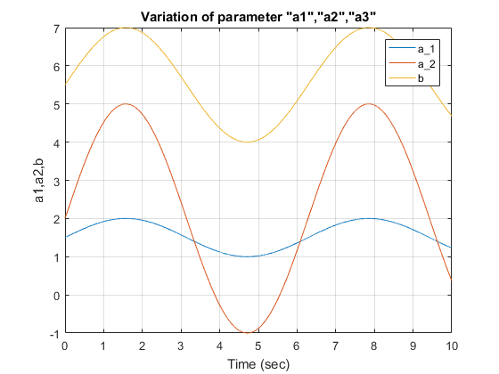

**Figure 8:** Variation of System Parameters, α1, α2, b

**PLOTS: SATURATION FUNCTION**

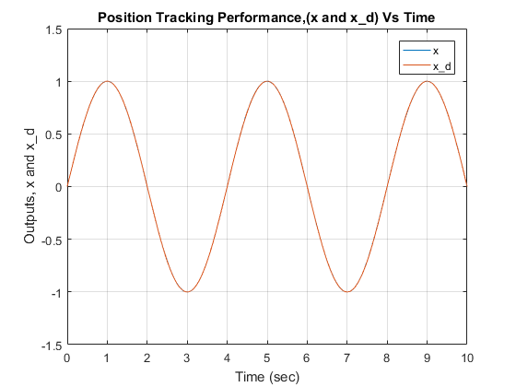

**Figure 9:** Position Tracking Performance

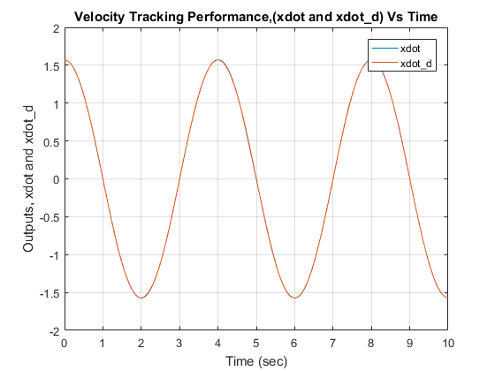

**Figure 10:** Velocity Tracking Performance

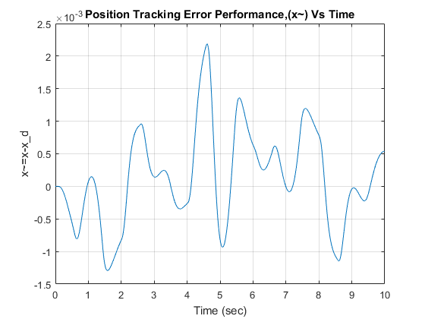

**Figure 11:** Position Tracking Error Performance

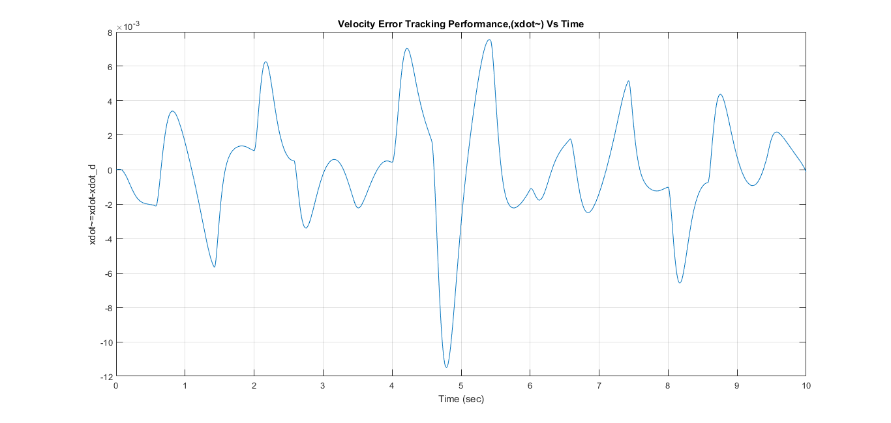

**Figure 12:** Velocity Tracking Error Performance

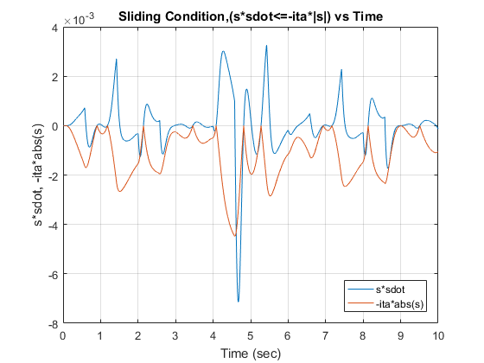

**Figure 13:** Sliding Condition

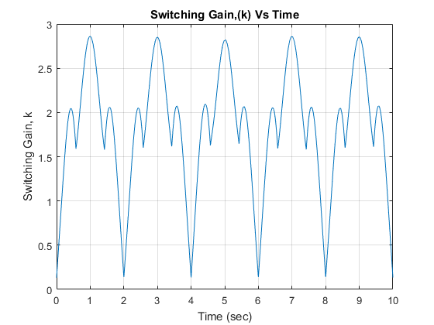

**Figure 14:** Switching Gain

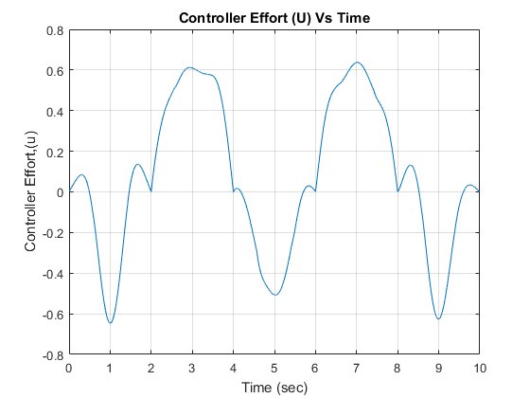

**Figure 15:** Controller Effort

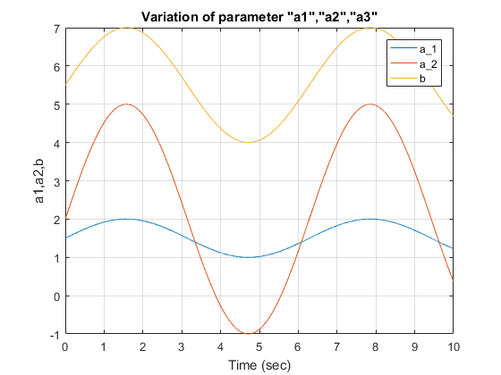

**Figure 16:** Variation of System Parameters, α1, α2, b

**SIMULINK MODELS**

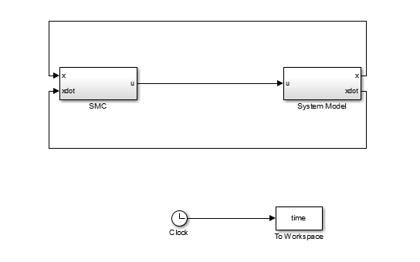

**Figure 17:** Main Block Diagram

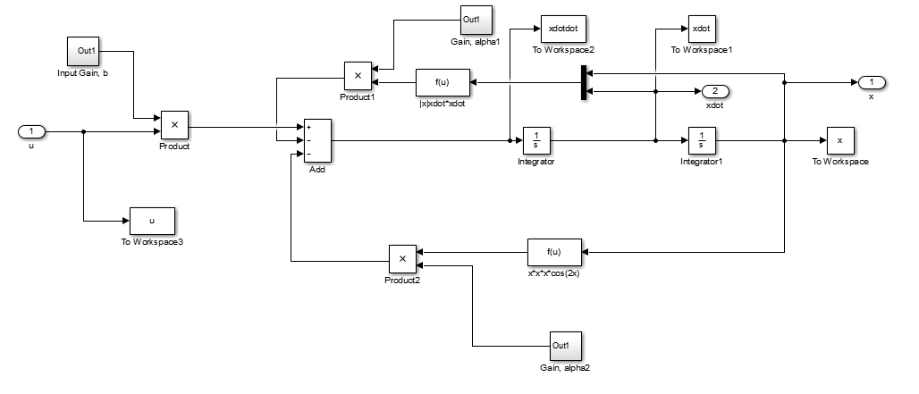

**Figure 18:** System Model

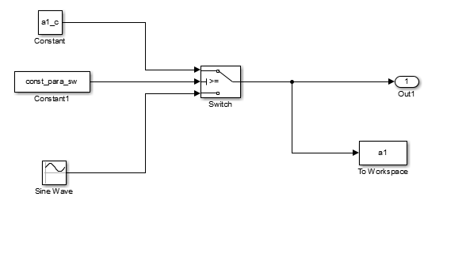

**Figure 19:** System Parameterα1

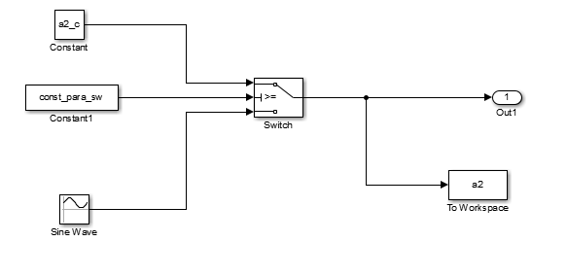

**Figure 20:** System Parameter α2

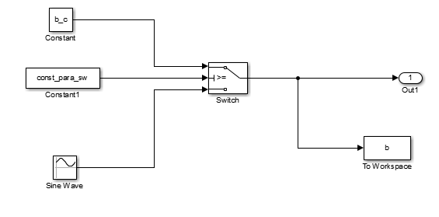

**Figure 21:** System Parameter b

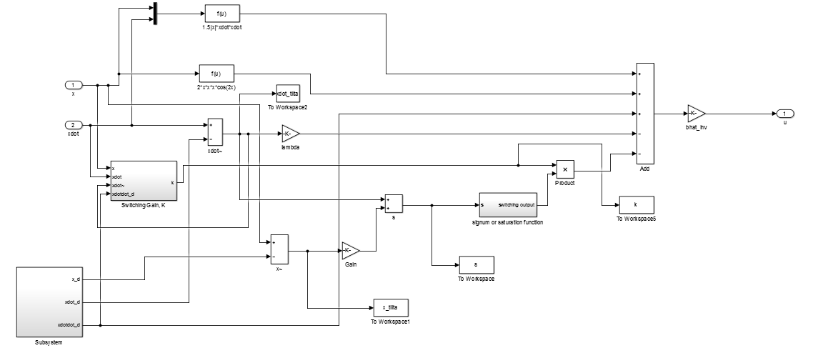

**Figure 22:** SMC Block

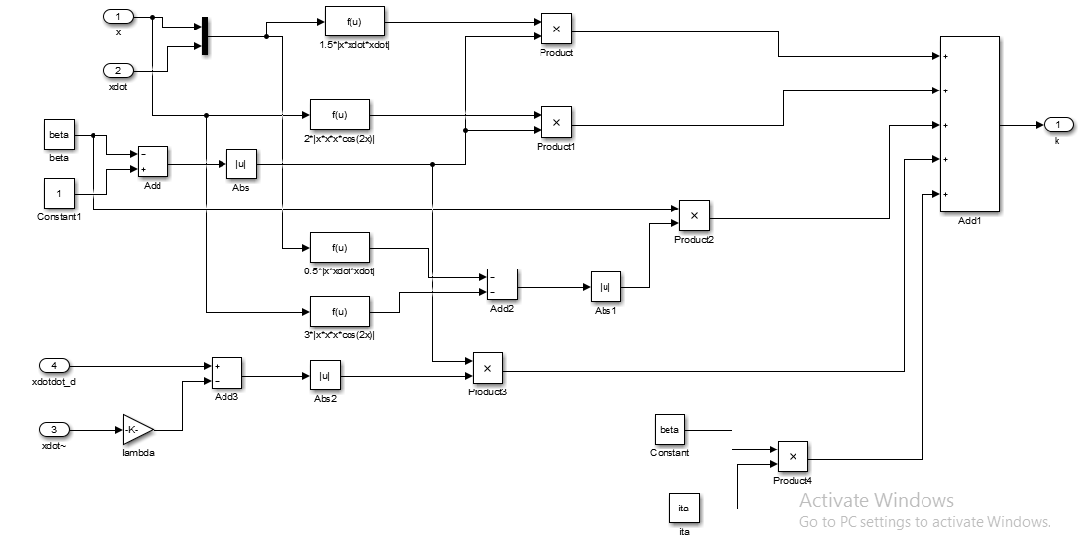

**Figure 23:** Switching Gain Block

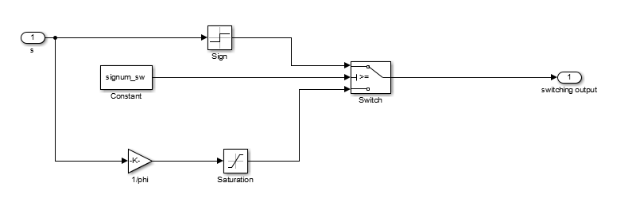

**Figure 24:** Signum / Saturation Function Switching Block

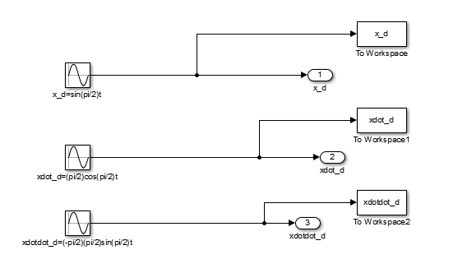

**Figure 25:** Desired Tracking Function Block

**MATLAB CODE**

%% Computer Project 4

%% Coded By K S Adarsh Raj

clear all,clc;

%% Switch between constant or varying system parameters

% const_parm_sw=input([1]:constant, [0]:vary);

const_para_sw=0;

if( isempty(const_para_sw) )

const_para_sw=0;

end

%% Switch betwewn Signum or Saturation Function

% signum_sw=input([1]:signum, [0]:saturation);

signum_sw=1;

if( isempty(signum_sw) )

signum_sw=1;

end

%% Define the Constant System Model Parameters

a1_c=1.5;

a2_c=2;

b_c=5.5;

%% Define Initial Condtions for x and xdot

x0=0;

xdot0=pi/2;

%% Define the SMC gains

lambda=20;

ita=0.1;

phi=0.1;

%% Define the upper and lower bounds for a1 and b

a1_upp=2;

a1_low=1;

b_upp=7;

b_low=4;

%% Define a1hat and bhat

a1hat=sqrt(a1_upp*a1_low);

bhat=sqrt(b_upp*b_low);

%% Define inverse of a1hat and bhat

a1hat_inv=1/a1hat;

bhat_inv=1/bhat;

%% Define alpha1 and beta

alpha1=sqrt(a1_upp/a1_low);

beta=sqrt(b_upp/b_low);

%% Run the simulation

sim('Project4');

%% Calculate sdot

sdot=(xdotdot-xdotdot_d)+lambda*(xdot-xdot_d);

%% Plot the Required Results

%Plot of x and x_d

figure(1),plot(time,x,time,x_d)

grid on

title('Position Tracking Performance,(x and x\_d) Vs Time')

xlabel('Time (sec)')

ylabel('Outputs, x and x\_d')

legend('x','x\_d')

%Plot of xdot and xdot_d

figure(2),plot(time,xdot,time,xdot_d)

grid on

title('Velocity Tracking Performance,(xdot and xdot\_d) Vs Time')

xlabel('Time (sec)')

ylabel('Outputs, xdot and xdot\_d')

legend('xdot','xdot\_d')

%Plot of x~

figure(3),plot(time,x_tilta)

grid on

title('Position Tracking Error Performance,(x~) Vs Time')

xlabel('Time (sec)')

ylabel('x~=x-x\_d')

%Plot of xdot~

figure(4),plot(time,xdot_tilta)

grid on

title('Velocity Error Tracking Performance,(xdot~) Vs Time')

xlabel('Time (sec)')

ylabel('xdot~=xdot-xdot\_d')

%Plot of Sliding Condition

figure(5),plot(time,s.*sdot,time,-ita*abs(s))

grid on

title('Sliding Condition,(s*sdot<=-ita*|s|) vs Time')

xlabel('Time (sec)')

ylabel('s*sdot, -ita*abs(s)')

legend('s*sdot','-ita*abs(s)','Location','SouthEast')

%Plot of Switching Gain

figure(6),plot(time,k)

grid on

title('Switching Gain,(k) Vs Time')

xlabel('Time (sec)')

ylabel('Switching Gain, k')

%Plot of Controller Effort

figure(7),plot(time,u)

grid on

title('Controller Effort (U) Vs Time')

xlabel('Time (sec)')

ylabel('Controller Effort,(u)')

%Plot of Varying Parameters

figure(8),plot(time,a1,time,a2,time,b)

grid on

title('Variation of parameter "a1","a2","a3"')

xlabel('Time (sec)')

ylabel('a1,a2,b')

legend('a\_1','a\_2','b')